Important Readings:

1. Mention some of the object class methods ?

Ans: equals, hashCode, wait, notify, notifyAll, clone (if cloneable is implemented), getClass

2. Access Modifiers

|  |  |  |  |  |
| --- | --- | --- | --- | --- |
| **Modifier** | **Class** | **Package** | **Subclass** | **World** |
| public | Y | Y | Y | Y |
| protected | Y | Y | Y | N |
| no modifier | Y | Y | N | N |
| private | Y | N | N | N |

3. [Super Class and Sub Class Exception](https://www.geeksforgeeks.org/exception-handling-with-method-overriding-in-java/):

If SuperClass does not declare an exception, then the SubClass can only declare unchecked exceptions, but not the checked exceptions.

If SuperClass declares an exception, then the SubClass can only declare the child exceptions of the exception declared by the SuperClass, but not any other exception.

4. Method on Exception object

ex.getMessage(), ex.getCause(), ex.getLocalizedMessage()

5. External Sorting - [here](https://www.geeksforgeeks.org/external-sorting/)

6. Arrays.asList(array) 🡪 **Returns a fixed-size list backed by the specified array, You can't add to it; you can't remove from it. You can't structurally modify the List.**

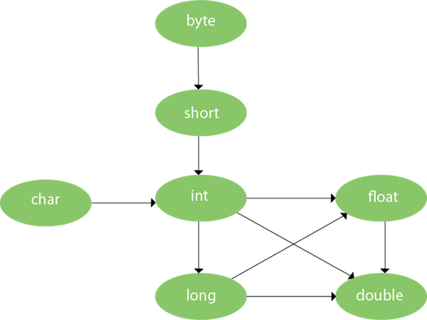

7. Static Class Loading vs Dynamic Class Loading

8. Interfaces are slower in performance as compared to abstract classes as extra indirections are required for interfaces.

9. Anonymous class ??

|  |  |  |
| --- | --- | --- |
|  | RDBMS | NoSQL |
|  | Structured Data | Unstructured Data |
|  | Highly Matured and standardized | Not so mature and different NoSQL DB’s have different standards |
|  |  |  |
|  |  |  |

[**NoSQL vs SQL**](https://blog.pandorafms.org/nosql-vs-sql-key-differences/)**:** [**When**](http://www.bmc.com/blogs/sql-vs-nosql/)[**should**](https://www.sitepoint.com/sql-vs-nosql-choose/) **we use which type of database?**

When the data must be consisten without leaving room for error when using a relational database. SQL.

When our budget won’t allow large devices and must be put into lower performance devices. NoSQL.

When the datastructures we manage are variable. NoSQL.

For analyzing large quantities of data in read mode only. NoSQL.

Event capture and processing. NoSQL

Online stores with complex intelligence engines. NoSQL

Int can be converted to char and not Integer. Hence we have to take int value from integer and then type cast it to char.

HashMap vs TreeMap vs LinkedHashMap - [here](https://www.geeksforgeeks.org/differences-treemap-hashmap-linkedhashmap-java/)

You must override hashCode() in every class that overrides equals(). Failure to do so will result in a violation of the general contract for Object.hashCode(), which will prevent your class from functioning properly in conjunction with all hash-based collections, including HashMap, HashSet, and Hashtable. – [here](https://stackoverflow.com/questions/2265503/why-do-i-need-to-override-the-equals-and-hashcode-methods-in-java) [here](https://www.geeksforgeeks.org/equals-hashcode-methods-java/). During the execution of the application, if hashCode() is invoked more than once on the same Object then it must consistently return the same Integer value, provided no information used in equals(Object) comparison on the Object is modified.